Beetle Project Overview and System Design

What is Project Beetle? The “Beetle” is a small self-guided wheeled robot that I have designed and developed as a platform to gain experience in the areas of electronics, programming, and embedded system design. At this stage the Beetle is not very useful, although the technology it showcases could be employed by applications such as household vacuum cleaners or lawn mowers.
The project began as a suggestion by my teacher, who once read an article like this (http://cyberneticzoo.com/cyberneticanimals/1969-emma-g-c-brown-british/ - search=%22xee%22 i.e. “EMMA,” a creature in the “cybernetic zoo”). My goal was to build a wheeled device smart enough to navigate a simple maze on its own, like a big, clunky “micromouse” (https://en.wikipedia.org/wiki/Micromouse). It would also have a mode in which it did nothing other than “explore” a room endlessly, making random decisions and therefore appearing to have rudimentary intelligence. This thought was largely influenced by the seemingly random manner in which a species of small jet-black beetle so enthusiastically explores the bathroom floor; hence the name.

Mechanical Construction and Design

Prototype Beetle is built out of various kinds of wood, MDF, bits of plastic, bicycle inner tube, nuts, bolts, washers, screws, glue, cardboard, and toothpicks! These materials were on hand at the time and for the most part they work fine, but version 2 could use a lot of upgrades.
The prototype consists of a central platform that serves as the chassis, two large wheels, and a front and rear bumper. Two electric stepper motors drive the wheels via two-pulley “transmissions,” and a rechargeable battery provides the entire system with electricity. Stepper motors were chosen because two identical ones were available (they had been reclaimed from a printer), and because programming the voltage supply for them would be an exciting challenge.

Chassis. The chassis is a plywood platform 9 mm thick and 180 mm long which would be a circle except that two sides are sliced away where the wheels go. The idea here is that the Beetle can pivot on the spot by rotating both wheels in opposite directions, and if there are any obstacles nearby they are not likely to get in the way because of the robot’s symmetrical design. There are two bits of hardwood glued to the top of the chassis near its center, which support the wheel axles. On the underside, the battery and motors are secured to four bits of hardwood, also glued to the chassis. There are also cut-outs in various places for wires to pass through and to allow for the large pulleys on the wheel axles.

Wheels & axles. The wheels are 145 mm in diameter, and their centers are positioned ~ 17 mm above the center of the chassis. This means that the Beetle’s center of mass lies below the point from which it is supported off the floor, and the chassis hangs like a pendulum from the wheel axles. The heavy components (the battery and motors) are placed underneath the chassis to enhance this effect; this means that the wheels must have a large enough diameter to keep these components from scraping on the floor. However, this pendulum effect is not enough to keep the chassis parallel to the floor at all times, as it tilts backward when the Beetle accelerates forward, and vice versa. To prevent too much tilt during forward acceleration, a “ski” (a bit of wood and plastic) is glued to the bottom of the chassis behind the starboard motor.
Each wheel is made of a plywood disc 6mm thick with a hole big enough to fit a 10 mm lock nut and washer, and a smaller MDF disc also 6 mm thick with a 10 mm hole. The smaller disc is fastened in the center of the larger one on the side facing away from the chassis, and a strip of inner tube is glued around the circumference of the larger disc to add grip.
The axles are actually two 10 mm bolts and their hexagonal heads rest above the center of the chassis, supported by the two bits of hardwood. The wheels are secured to the other ends of the bolts, sandwiched between a lock nut and a regular nut (the lock nut on the inside). Attached to either side of the chassis is a vertical MDF panel 4 mm thick; inset into this panel at the height of the axle is a solid piece of plastic about 6 mm thick through which a hole is drilled, just large enough to fit the axle with a minimum of friction (Wd-40 helps). Thus the chassis and everything on it hangs from the axles via these DIY “bearings” just inside the wheels.

Transmission. This part of the mechanical design took the longest to develop. A gearbox featured in the original design, but this method had a couple of problems. First, there were too many parts and too much complexity, and I discovered that I could not build a reliable gearbox on such a small scale using MDF, nail shafts, and plastic gears, as was my intention. Second, even when it was almost working, the gears would rattle excessively because of the way a stepper motor works: the motor shaft would only rotate a little bit at a time, and this resulted in a series of starts and stops in quick succession rather than continuous movement. This second problem might be solved by higher rpm and micro-stepping the motors, and proper tools and materials would solve the first, but it proved far simpler to use a different system altogether.
The Beetle now uses a two-pulley system to connect the motors to the wheels. On each motor shaft is a brass gear about 9mm in diameter and 6mm long. Directly above this gear (pulley1) is a second pulley (pulley2) made of plywood, 11mm thick and 63mm in diameter. Pulley2 is firmly threaded onto the wheel axle, and a thin section of inner tube (i.e. a “rubber band”) stretches around both pulley1 and pulley2, acting as a “flat belt.” The convex surface of pulley2 and a pair of toothpicks between the two pulleys act as guides to keep the belt on track. The belt has lots of give and easily absorbs any jolting action of the motor.
The (pulley1 : pulley2) ratio is about (6.5 : 1), but since the actual wheel has a circumference of ~ 455.5 mm, the distance travelled per motor revolution is about 70 mm. The motor performs 1 revolution every 48 full steps, and this means about 1.46 mm of lateral distance per full step, or 0.73 mm per half step. While this may not be geared down enough for peak motor performance, it is adequate for this application since the belt will slip long before any great amount of torque is required from the motor.

Bumpers. At the Beetle’s front and back is a bumper carved out of construction lumber, about 5 mm thick and 25 mm in height. Each fits around a curved end of the chassis, so that the top rim is aligned with the chassis surface and the rest hangs down. All along the bumpers are cut-outs and holes to admit electronic sensors which will be detailed later. The purpose of these parts is not so much to prevent damage as to provide something solid to attach electronics to, at the same time concealing a mass of wires and components.
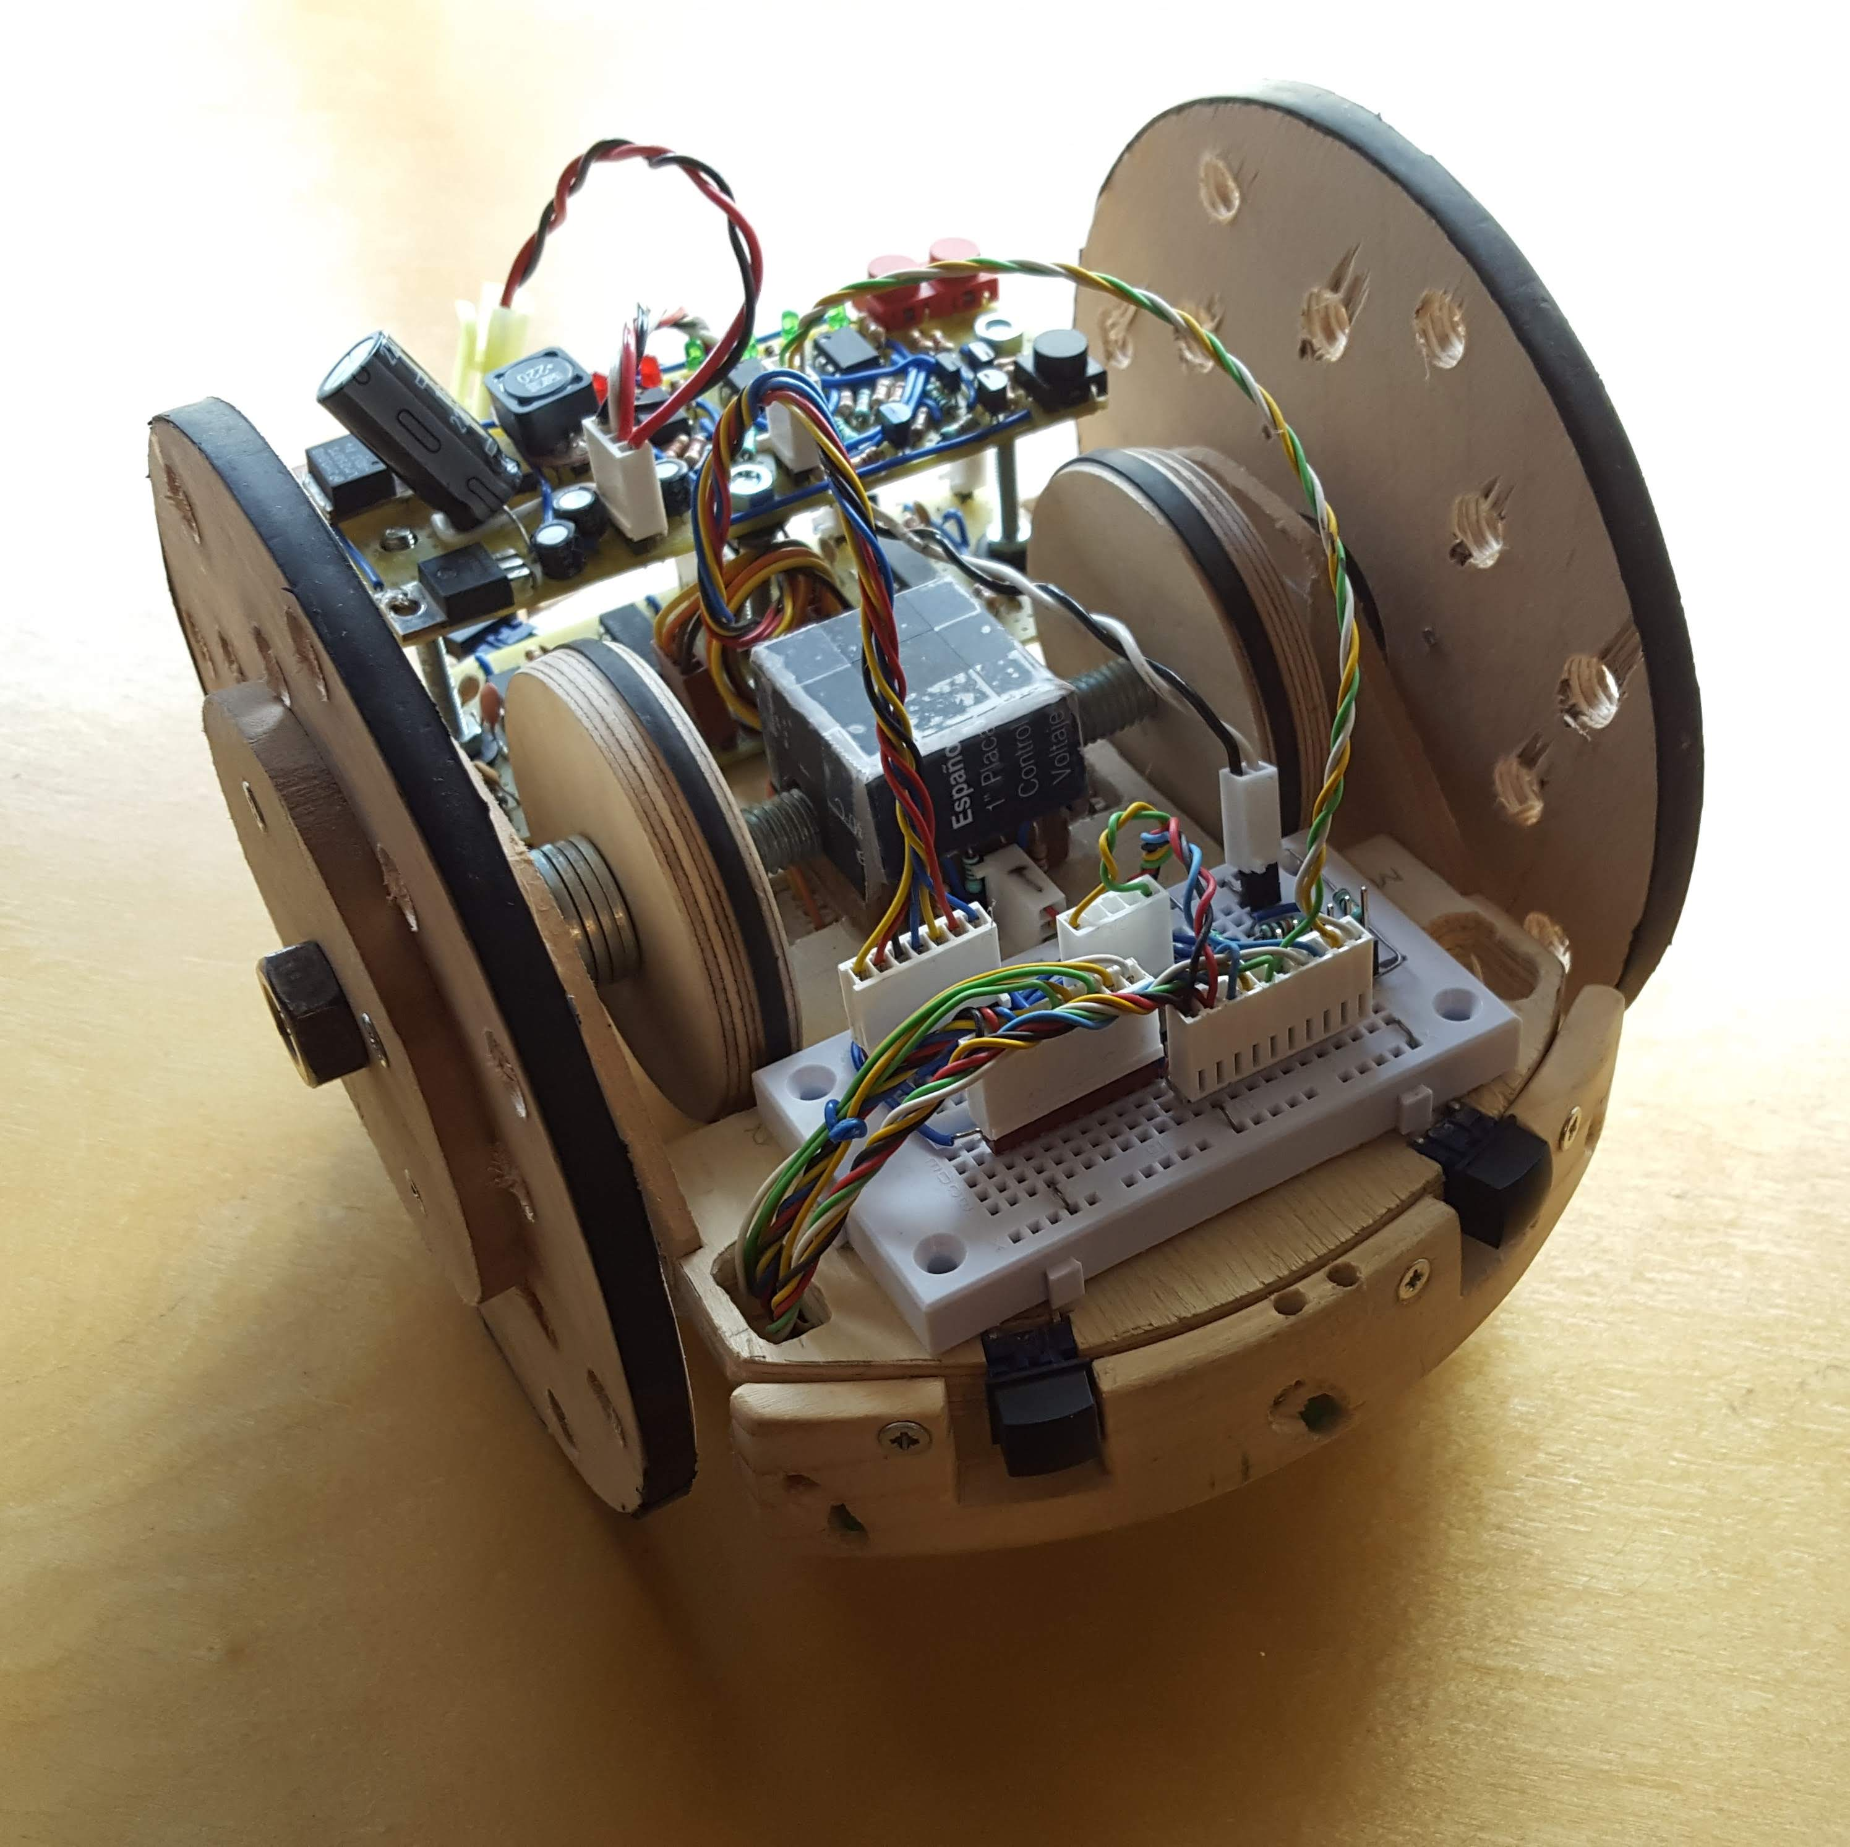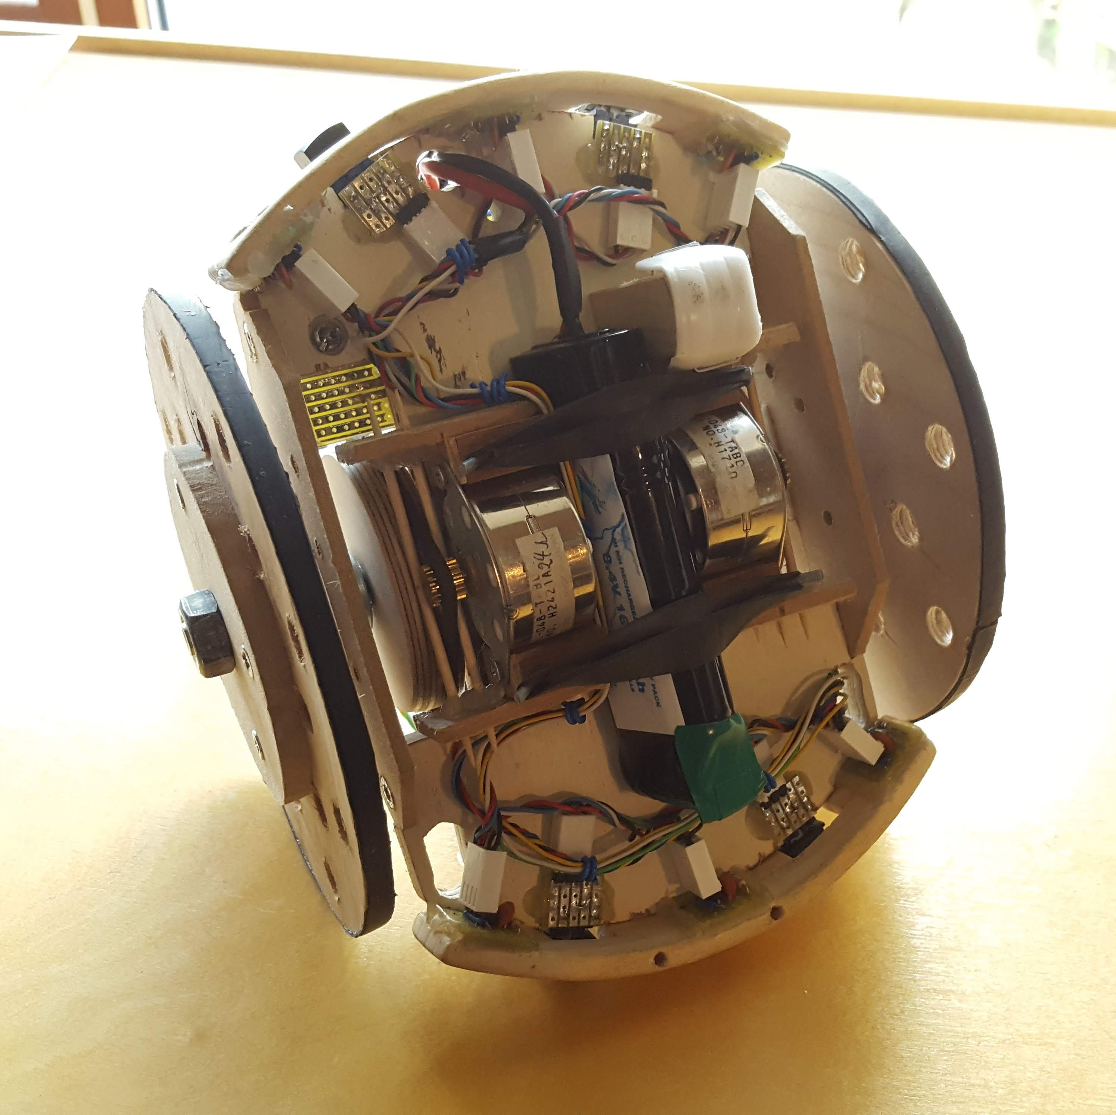

Electronics Hardware Design

In order to accomplish the aim of autonomous mobility, the Beetle needs a few basic features:

- the ability to move, i.e. to control its own motors
- an array of sensors by which it can detect walls and obstacles
- a central “intelligence” that can respond to input sensor data with appropriate movement commands.

A mobile power source (a battery in this case) is necessary to provide the system with electricity, and there must be an interface through which a human can give the Beetle high-level commands.
An embedded computer system fulfils these criteria; it consists of a microcontroller and a series of peripheral electronic circuits (see Figure 1). Of these, there is a circuit dedicated to driving the motors, eleven separate circuits containing sensors, a circuit tied to power conversion and monitoring the battery voltage level, and two “master pushbuttons.” See Figure 1 for a schematic of the entire system.
The peripheral circuits have been made of through-hole components and prototyping stripboard, while a small breadboard holds the microcontroller itself. This arrangement has made it relatively straightforward to replace or rearrange parts during development.

Microcontroller. The “brain” of the system is a pic18F26k22 microcontroller manufactured by Microchip Technology Inc; its datasheet can be found here (https://www.microchip.com/stellent/groups/picmicro_sg/documents/devicedoc/cn547043.pdf). This device has 64 kbytes of flash program memory and 4096 bytes of data memory, plus EEPROM. The CPU uses a RISC architecture optimised for C programming, and an internally supplied oscillator structure allows selectable clock frequencies of up to 64 MHz. To program the device, a PC running Microchip’s MPLAB8 or MPLABX IDE software is connected to the “programming port” (see Figure 1) via the company’s ICD 3 debugger/programmer hardware unit (see this poster: http://ww1.microchip.com/downloads/en/devicedoc/mplab_icd3_poster_51765a.pdf).
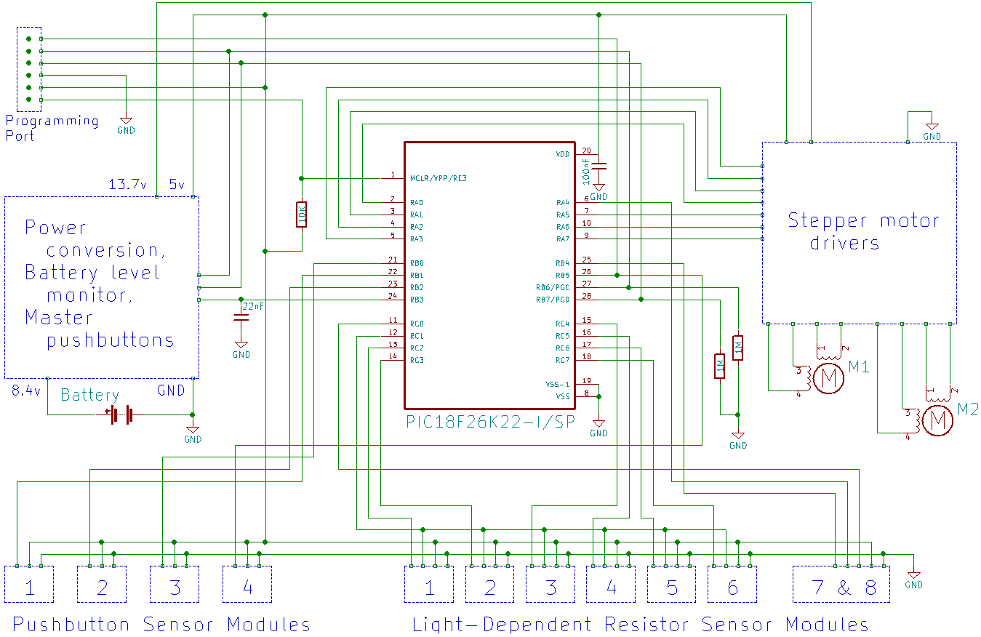Figure 1: Grand Schematic

Currently a simple six-pin header connects the ICD 3 to the device, but this could be upgraded to an RJ-11 standard plug.
The microcontroller lives at the “head” of the Beetle on its breadboard just in front of the pulleys on the wheel axles. From here, custom made cables transfer signals to and from the rest of the system, and it is supplied with five volts and ground via a cable from the power conversion circuit.

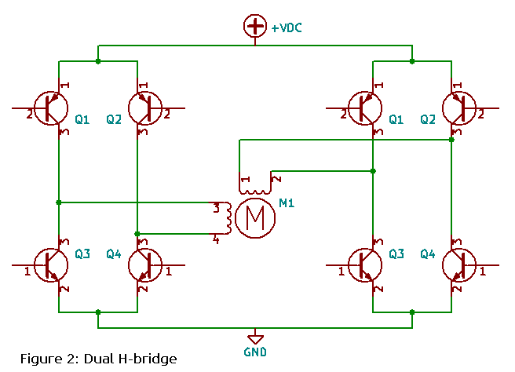
Stepper motor drivers. A pair of identical stepper motors (manufactured by Minebea electronics, product name “PM35L-048”) located underneath the main chassis drives the wheels. See this page (https://www.eminebea.com/en/product/rotary/steppingmotor/pm/standard/pm35l-048.shtml) for motor characteristics; in short, they are 2-phase motors with 48 full steps per rotation, rated for 500 milliamps at 24 volts, and can be wired for unipolar or bipolar modes. They provide more than enough torque for this application.
The motors are driven in bi-polar configuration; that is to say, each motor “phase” consists of one electromagnetic coil, or “winding.” As there are two phases per motor, they are turned on and off in a sequence designed to alternately attract and repulse the poles of a permanent magnet on the motor shaft, thus causing rotation. This is done with a circuit called a “dual h-bridge” which looks something like Figure 2 – the inputs of the transistors are toggled in such a way that current can flow through the motor windings in either direction or not at all.
This process is made simpler by utilising an IC – a stepper motor driver – that makes use of this design and takes care of all the details. The Beetle uses the L6219, manufactured by STMicroelectronics (datasheet here https://www.st.com/resource/en/datasheet/l6219.pdf). It requires some external circuitry to configure the current limiting parameters and has six digital inputs for user control and two output stages that deliver current to one motor winding each. Two of these IC’s are required for this application since there are two motors.
The full schematic of the stepper motor driver circuit is given in Figure 3. This circuit is built onto a 106 x 43 mm panel of stripboard, and it lives on the chassis in the space behind the axles and pulleys.

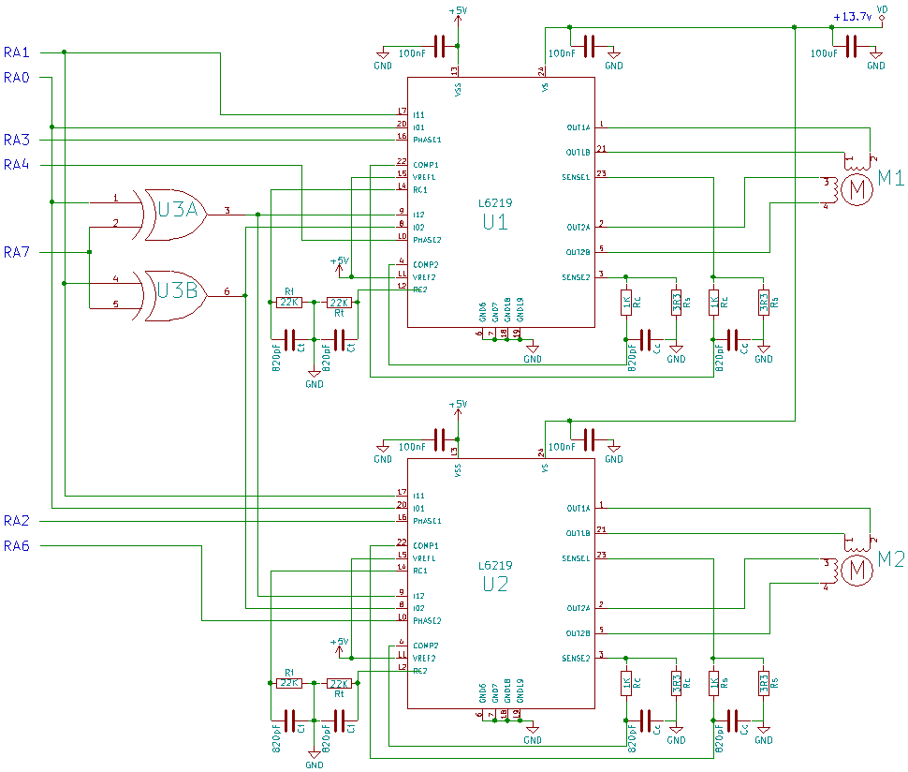Figure 3: Stepper Motor Driver Circuit

Notice from Figure 3 that there are two separate supply voltage inputs to the L6219. “Vs” is the load supply that is ultimately fed to the motors, while “Vss” drives the logic circuitry in the unit.
Of the digital inputs to the L6219, there are two phase inputs (ph1 & ph2) that control the direction in which current flows through the motor windings, and four logic inputs (I01, I11, I02, I12 – two per winding) that select among four current levels: 100%, 67%, 33%, or 0% (off). This allows for full-stepping and half-stepping; micro-stepping could be accomplished by varying VREF instead of fixing it at five volts as in this case.
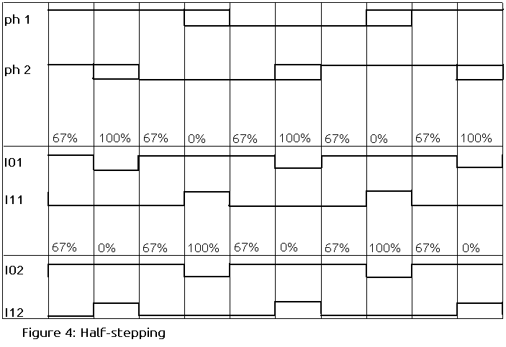
I chose to use half-stepping because it is straightforward given this design and a comparatively smooth motor operation is a desirable feature, while the complexity of micro-stepping is avoided. In a half-stepping scheme, the rotor is attracted alternately by only one phase and then by both phases simultaneously. This creates the problem that the rotor experiences a greater pull by both phases working together than one by itself – the result is uneven torque. The solution to this problem is to operate one phase at 100% current and the other at 0% when one is working by itself, and both at 67% current when they are working together. Figure 4 shows the waveforms input to the L6219 over time in order to accomplish half-stepping. Whether the rotor rotates clockwise or counter-clockwise is determined by the phases – invert one phase (or shift it 180 degrees), and the rotation is reversed. To turn the motor off, simply tie all the logic inputs high (both phases at 0% current).
As there are two stepper motor drivers to take into account, and each has six inputs, I could have assigned all twelve inputs their own microcontroller pins. However, these pins are valuable real estate and I wanted to use as few as possible. It was no good trying to combine phases – at least not without complications – since each motor’s direction must be independently controlled. I could, however, send identical logic signals to both units at the expense of not being able to hold one motor still while the other rotates. Furthermore, notice from Figure 4 that waveform “I12” is the inverse of “I01,” and similarly “I02” is the inverse of “I11.” Consequently, the addition of two logic inverters to the circuit decreases the number of necessary logic waveforms from eight to two. However, it must be possible to shut both motors off by tying all logic inputs high, which does not work if only an inverter is used. The solution is to use an X-OR module instead: feed the two logic waveforms into its first and fourth pins, and toggle its second and fifth pins with a third digital signal from the microcontroller to turn the “inverter” on or off (see Figure 3). Thus, seven lines total are required for the microcontroller to communicate with the stepper motor drivers.

Sensors. Without a way of detecting its surroundings, the Beetle would be somewhat useless in the real world. It must be able to determine if it has hit a wall or gotten stuck in some other way, as this is an appropriate time to take evasive action. To this end, there are six “photosensor” modules and four “pushbutton” modules arrayed around the front and back bumpers, positioned to detect a collision with a wall or other hard object. As there proved to be many situations in which this system – the “collision detectors” – would not realize that the Beetle was stuck, there are two more photosensors that look at the wheel axles to see if they are turning. These are photosensor modules “7 & 8,” a.k.a. the “wheel rotation sensors.”

Photosensors. Each of these consists of a small panel of stripboard to which is soldered a green LED, a light-dependent resistor (LDR) in a voltage divider circuit, and a low-pass RC filter (see Figure 5). The LDRs used in prototype Beetle have part number VT935G and the datasheet can be viewed here: https://datasheet.octopart.com/VT935G-EG%26G-datasheet-6396822.pdf. Since the LDR voltage divider does not generate a smooth waveform, the RC filter is designed to remove sharp edges from it. This assists the detection software.
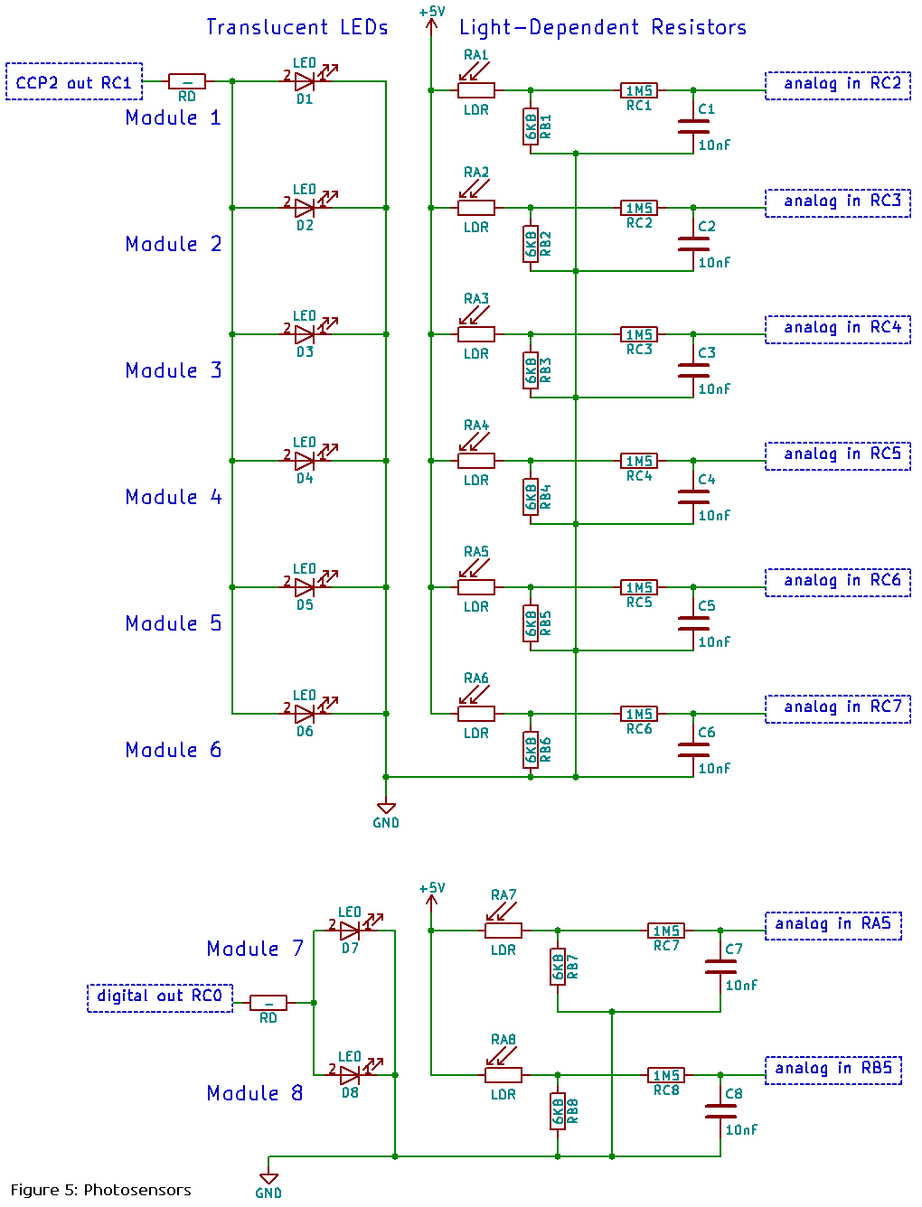
- Collision detectors. In these units, the LED and LDR are actually soldered onto the metal side of the stripboard and protrude through holes in the bumper, facing outward. A square wave at about 7.5 Hz is output from the microcontroller to the LED, and software in the microcontroller monitors the return signal from the potential divider for the same frequency. Now, as long as the Beetle stays in the clear, very little of the LED light reaches the LDR, and it is highly unlikely that said frequency will register in the return signal. When the Beetle bumps into an adequately reflective surface, however, light from the blinking LED is reflected into the LDR, causing collision detection.
As the LDR response time is relatively slow, a frequency as low as 7.5 Hz must be used. Also, the signal detection software used at present is only suitable for low frequencies. Rather than being irritating, however, the visibly blinking LEDs only add to the overall cuteness of the Beetle!
- Wheel rotation sensors. Photosensor modules seven and eight are not used in direct collision detection, but instead they monitor the wheel axles to see if they are rotating. They go about this task by focusing on the hexagonal heads of the bolts, at ninety degrees to the axis of rotation. This means that, per module, there are six reflective faces that take turns directing LED light into the LDR as the axle makes one rotation (these LEDs do not oscillate, but simply illuminate the bolt heads). Internal software monitors the return signal, checking that an undulating waveform exists. If one cannot be detected, it is assumed that the wheel has ceased to turn, meaning the Beetle has gotten stuck.
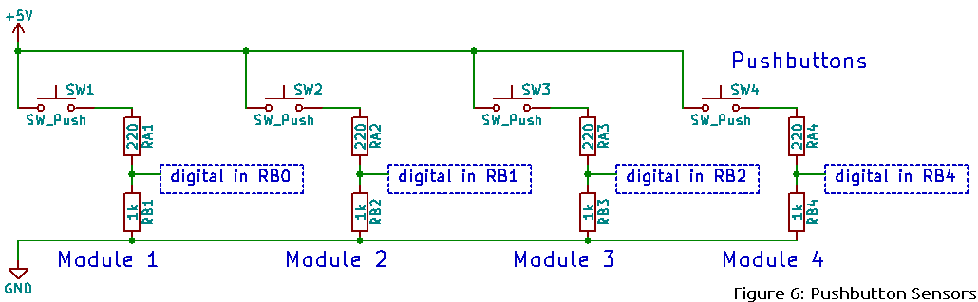
This system tends to fail in conditions with any amount of ambient light, since this weakens the effect of the LEDs. Prototype Beetle overcomes this problem with a box made of non-reflective black cardboard that isolates the bolt heads and photosensors from the outside world.

Pushbutton Sensors. The pushbutton modules add redundancy to the collision detection system. They are exactly what they sound like: pushbuttons facing outward from the rim of the chassis, protruding through holes in the bumpers. They are positioned to actuate when the Beetle bumps into something solid (like a wall). As the schematic shows in Figure 6, the microcontroller inputs are tied to ground via 1 kΩ by default; but when a pushbutton is pressed, its circuit turns into a voltage divider that generates a four-volt signal.

Power conversion / Battery level monitor / Master pushbuttons. These last peripherals share a 107 x 39 mm panel of stripboard that is fixed above the motor driver circuit, held above the chassis by three 3 mm bolts.

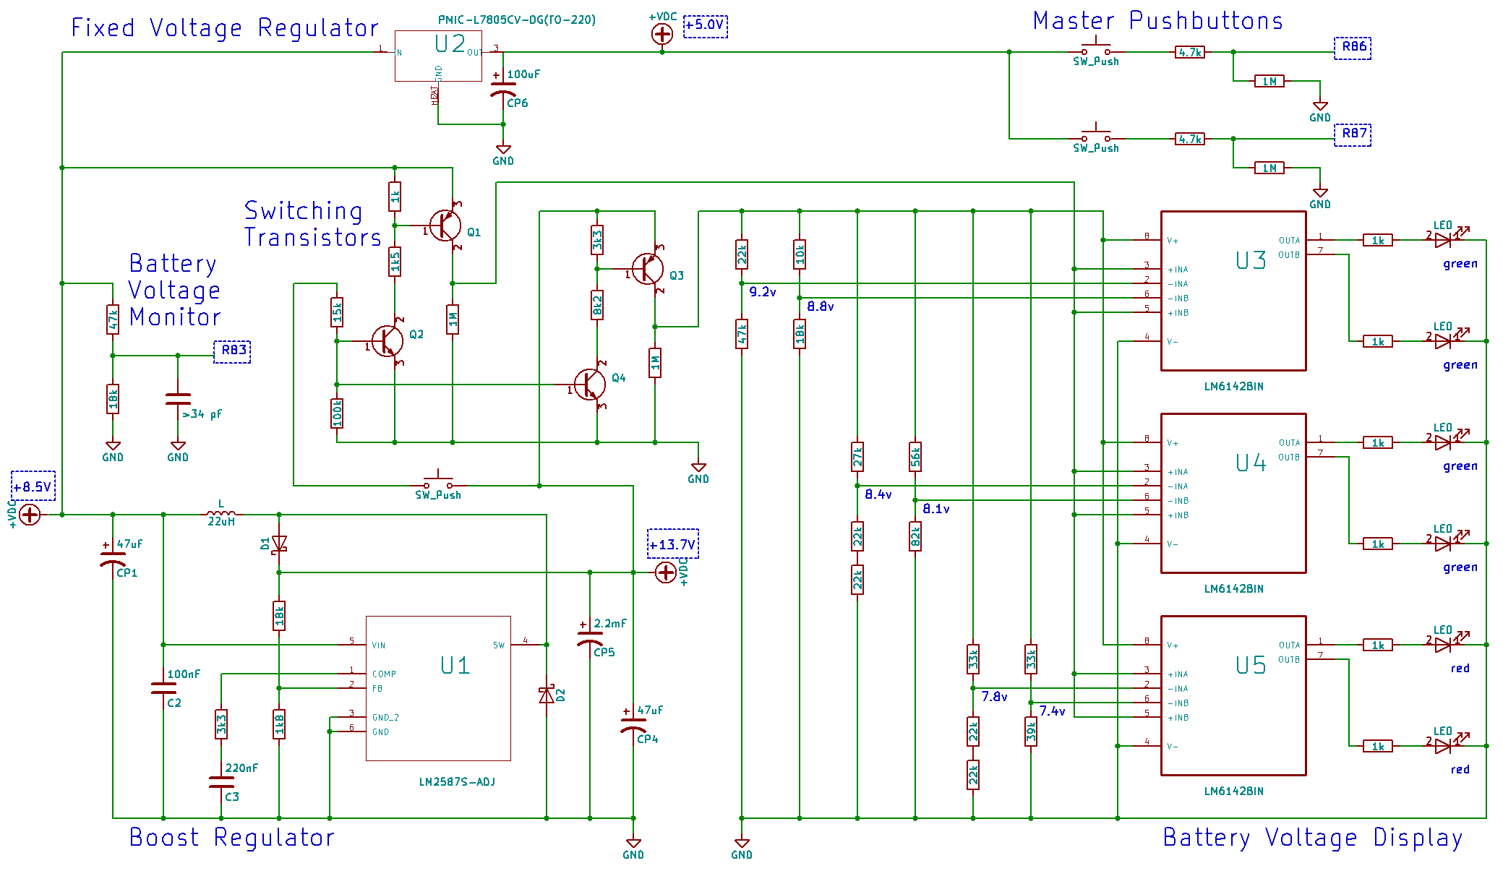Figure 7: Power conversion / Battery level monitor / Master pushbuttons

Power supply. A seven-cell nickel-metal hydride (NiMH) rechargeable battery powers the Beetle. This choice was largely influenced by size and shape, as the battery must be long and thin in order to fit between the two motors underneath the chassis. The battery has a capacity of 1600 milli-amp hours and a nominal voltage of 8.4 volts. Most of the Beetle’s electronics operate at 5 volts, however, which means a step-down regulator is needed. The motors themselves are rated for 24 volts and can be operated at much less than that, but the stepper motor drivers must route a minimum of 10 volts to the motors; thus, a boost regulator is also required.
- Step-down voltage regulator. The LM7805 (datasheet here: http://www.ti.com/lit/ds/symlink/lm7800.pdf), a linear fixed voltage regulator shown in Figure 7 as “U2”, reduces the battery voltage to 5 volts. From here, power is supplied to the microcontroller and the rest of the system.
- Boost regulator. As the transmission design does not allow the Beetle to take full advantage of the motor torque, there is little point in operating the motors at their rated 24 volts. In fact, in this application a lower voltage has the advantages that the motors consume less power and they run more quietly.
It proved convenient to boost the battery voltage to 13.7 volts using the LM2587S-ADJ as a switching regulator (datasheet here: http://www.ti.com/lit/ds/symlink/lm2587.pdf). In this scheme, inductor L accumulates energy as its current rises, while a transistor inside the regulator (U1) is turned on. This transistor turns off when the inductor current reaches a level determined by the voltage applied to input “FB,” or “feedback”. At this point, the inductor transfers its stored energy to capacitor CP5, which slowly discharges into the load, and the cycle repeats.

Battery level monitor. When the battery runs out of “juice,” it is not good for the Beetle to keep on trying to function. For one thing, as the battery runs low, its voltage level decreases, and if it falls below a certain point – about 7.4 volts in this case – it risks being damaged. For another, too low a voltage from the battery could result in other damage should any circuitry fail as a result.
- Voltage monitor. To prevent these events, it is necessary for the Beetle to detect when its battery falls below 7.4 volts and to take appropriate action (shut down) in such a case. This is accomplished by channelling the battery voltage through a voltage divider where R1 = 47 kΩ and R2 = 18 kΩ, and sending the output voltage to the microcontroller. A comparator module inside the microcontroller compares this voltage to an appropriate internal reference voltage, and a software trigger is set when the two voltages are the same. The specific values for R1 and R2 were chosen to output 2.05 volts when the battery level reaches 7.40 volts; this output could then be compared with the microcontroller’s internal fixed voltage reference of 2.048 volts. In practice this does not work because the output voltage is too noisy, meaning a voltage spike triggers the comparator before the battery actually reaches 7.4 volts. Hardware and software filtering helps to mitigate this issue, but does not take it away completely. Consequently, the microcontroller’s digital-to-analog converter module is used in place of the fixed voltage reference, and a value is chosen below that of the target 2.05 volts.
The hardware filtering consists of a ceramic capacitor between the output of the voltage divider and ground. Resistor 1 of the voltage divider works with the capacitor as a low-pass filter, removing much of the noise. Note that this capacitor is also shown in the grand schematic (Figure 1), as it is physically located on the breadboard beside the microcontroller.
The software “filter” is really a de-bouncing sequence that comes into play when the comparator first triggers. When this happens, the comparator output is sampled about once every 1.5 microseconds over a total period of about 30 microseconds. If the comparator consistently shows that the battery voltage is equal to or less than the reference voltage, then the Beetle is shut down. On the other hand, should the comparator change its mind and indicate that a bit of noise was the cause, then the shutdown sequence is aborted.
- Voltage display. It is also useful for the user to know what the battery level is, and thus how much longer the Beetle will last. To this end, a row of four green and two red LEDs light up at the touch of a pushbutton, visually representing the voltage level of the battery. Each LED is connected to the output of an operational amplifier, or “op-amp.” These op-amps are used as comparators – their only job is to compare the battery voltage with six consistent reference voltages generated by a series of voltage dividers.
This arrangement requires that two separate voltages be directed to the display apparatus when the user desires to see the battery level: one of these is the battery voltage to be tested, and the other a higher, stable voltage to power the opamps and voltage dividers – in this case 13.7 volts from the boost regulator. However, for the sake of convenience only one pushbutton should be used, which means a set of “switching transistors” is necessary to turn both voltages on and off instantly and reliably.
1. op-amps. To compare voltages and power the LEDs, the 8-pin version of the LM6142 op-amp is used (datasheet here: http://www.ti.com/lit/ds/symlink/lm6142.pdf). Inside each unit (U3, U4, and U5 in Figure 7) are two op-amp modules (A and B), each with three pin connections: an inverting input, a non-inverting input, and an output. In each case, the non-inverting input is connected directly to the battery, the inverting input is connected to a reference voltage, and the output is fed to an LED via a current limiting resistor of 1 kΩ. As already stated, the supply voltage comes directly from the boost converter; this is guaranteed to be a greater voltage than that of the inputs, regardless of the battery level. In this way, if the pushbutton is depressed and the battery voltage is greater than the reference voltage, the LED is on; otherwise, it is off. When the pushbutton is not depressed, all op-amp inputs and supply voltage pins are tied to ground via 1 MΩ resistors.
Unfortunately, this choice of op-amp complicates the design; it would have been better to use stand-alone comparators optimized for this application. The main problem is that, due to some technicality of the op-amps, the voltage on one input is not dependant solely on the external circuitry, but fluctuates as the voltage on the other input varies. However, this does not strictly affect the op-amp’s capability as a comparator, since the change in the output still occurs when expected.
2. voltage dividers. Six separate voltage dividers, driven by the same supply that powers the op-amps, output reference voltages at different points within the range that the battery covers as it depletes. The battery begins its life cycle well above 9 volts, ends it at 7.4 volts, and spends the most time in the vicinity of 8.4 volts. Therefore, given a supply voltage of 13.7 volts, the reference voltages are calculated to be 9.2 volts, 8.7 volts, 8.4 volts, 8.1 volts, 7.8 volts, and 7.4 volts.
Actually the end result does work quite as planned, the problem being that when an op-amp module is powering its LED, it pulls the supply voltage down to something less than 13.7 volts; furthermore, this effect appears to vary in magnitude among individual units. Consequently the supply voltage is not a fixed value, but varies according to how many LEDs are turned on at any one time. As a result, the reference voltages at the high end of the scale fall short of their calculated value when they matter, since all or most of the LEDs are on at that time.
Rather than using six individual voltage dividers, the original plan incorporated a single one consisting of a string of resistors with outputs in six places. This would reduce the number of resistors required for the application. Regrettably this design fails because of the op-amps’ fluctuating input problem – as the non-inverting inputs vary with the battery voltage, the inverting inputs (which are connected to the voltage divider) fluctuate as well. The result is disastrous, since an unexpectedly fluctuating voltage at any point in the voltage divider messes up the calculations for the whole thing.
3. switching transistors. Since it would be inconvenient to leave the LED display on at all times, the user must be able to turn it on and off at will, and this involves switching two separate voltage levels simultaneously: the battery voltage and the supply voltage. Refer back to Figure 7 for a schematic of how this is done. In effect, the circuit consists of a pushbutton and two sets of transistors, one for each voltage level; each set contains an upper stage with a pnp transistor (Q1 and Q3) and a lower stage with a npn transistor (Q2 and Q4). When the pushbutton is pressed, current is supplied to the base of transistors Q2 and Q4, which subsequently go into saturation. The effect of this is to allow current to flow through voltage dividers in the upper stages, applying a voltage to the base of transistors Q1 and Q3 which is less than that applied to their emitters. These transistors then go into saturation as well, allowing current to flow through the load.

Master pushbuttons. An important part of any device is the interface through which the user interacts with it. At present the Beetle’s human-machine interface is quite primitive, consisting only of two pushbuttons. Pushbutton 1 starts or stops the Beetle wandering around randomly, and pushbutton 2 initiates a show-off sequence in which the Beetle demonstrates what it can do.
When one of these pushbuttons is pressed, a little less than five volts from the fixed voltage regulator is delivered to the input pin on the microcontroller (RB6 or RB7), and firmware takes over from there. At other times, the pins are tied to ground via 1 MΩ resistors, shown both in Figure 7 and the grand schematic (Figure 1). Since pins RB6 and RB7 are also used by MPLABX debugging software, the pushbuttons should not be used during a debugging session.

Firmware

The hardware and electronics, already detailed, are the means by which the Beetle interacts with the physical world. Similar to the way we assess our surroundings using our eyes, ears, nose, and touch, the Beetle’s only way of sensing its surroundings is through its collision detection and wheel rotation sensors. Conversely, we use a frame of bones and muscles to move about in and make changes to this same physical world; similarly the Beetle has the option of trundling along on its pair of wheels.
At the center of these interactions with the physical world is the microcontroller, which could be thought of as an extremely primitive “brain.” It is programmed to analyze the incoming signals from the sensor modules and master pushbuttons, determine what to do based on this information, and send the appropriate signals to the motor drivers.

Overview. This program – the firmware – is written in the C programming language, compiled into Microchip’s MPASM assembly language using their XC8 compiler, and loaded to the PIC18 microcontroller in the form of opcodes (see the microcontroller section). The entire development process took place in the company’s MPLABX integrated development environment software on a desktop PC.
“main.c”
#include “beetle.h”
main( )
{ mainloop( )
}
“MotorControl.c”
#include “beetle.h”
sing( )
move( )
pivot( )
rand( )
“PhotoSensor.c”
#include “beetle.h”
start_signal( )
stop_signal( )
signal( )
“MainFunctions.c”
#include “beetle.h”
Dbounce_us( )
interrupt T2( )
“beetle.h”
#defines &
global
declarations
The firmware consists of four source files – main.c, MotorControl.c, PhotoSensor.c, and MainFunctions.c – and a header file, beetle.h. This header file contains global variable declarations and preprocessor definitions and macros that are used in multiple files; as such, it is included in all the source files. Another header file is included in all source files, <xc.h>; this ensures that all the features of the specific compiler and PIC device can be accessed from the source file.
Figure 8: firmware
layout
At the start of the file “main.c,” initial configuration bit settings “set up” the microcontroller, establishing such things as what oscillator structure to use, whether special peripherals are enabled or not, and the like. Then external function prototypes (defined in the other source files) are declared, and the global variables declared in “beetle.h” are defined. At this point begins the function main(), the entry point of the program; here, some more configuration takes place after which an infinite while loop – mainloop() as it will henceforth be called – executes code as necessary. The other source files contain functions associated with some particular part of the Beetle functionality, and these are called by mainloop(). It should be noted that although many processes in the program poll interrupt flags, there is only one operation (motor control) which actually uses an interrupt.

Main. Function main() in the file “main.c” is like the glue that holds everything together, or the central hub where everything happens. The first thing that happens after a device reset is a bit of setup (note that this is not the same as setting up the configuration bits). Here, the device is programmed to run at 32 MHz, global interrupts are enabled but interrupt priority levels are not, input/output ports are set up as needed, comparator module 1 and the digital-to-analog-converter module are initialized to monitor the battery level, and local variables are defined.
After setup, the program spends the rest of its time in the infinite mainloop() which is broken by nothing other than a device reset. Here, the program knows when to execute a process by polling a flag that indicates whether or not that process needs to be done. Of these processes, a “state machine” handles sensor inputs and responds accordingly, photosensor waveforms are analyzed, an optional sequence causes the Beetle to wait half a second before executing a move() command, another sequence makes the Beetle do a random turn or pivot every once in a while, master pushbutton events are detected and de-bounced, and the battery voltage level is monitored. The more detailed of these are summarized here.

State machine. Here, the “state machine” refers to a construct, located in mainloop(), that maps sensor input conditions to their appropriate reactions. First, there has to be a way of detecting an “event,” which happens if a photosensor or pushbutton sensor module sets off. A pushbutton sensor module has triggered if a positive voltage is present on the corresponding input pin, a collision detection photosensor module has triggered if a wave is present on its input signal, and a wheel rotation photosensor module has triggered if a wave is not present on its input signal. Twelve individual bits of a 16-bit data register dubbed ‘STATE’ indicate whether a sensor module has triggered (1) or not (0). Every iteration of mainloop(), ‘STATE’ is updated and then compared with its old value. If the two are the same, nothing has happened; but if the two are different and the new value is not 0, then an event has taken place and the new value of ‘STATE’ indicates which event or combination of events it is.
An event having been detected, an appropriate reaction must be set in motion. This reaction has, in most cases, three steps: back away from the obstacle first (or go forward if a rear sensor triggered the event), turn or pivot, and then proceed forward. Each segment of the reaction is “on a timer” – a variable ‘bb’ increments every so often until it reaches a stop value ‘bb_stop.’ At that point a software event is triggered in the same way that hardware sensor events are detected, and the next step of the reaction begins. The program knows what step comes next by means of a variable ‘reaction’ that was given a value when the previous step began.

User interface. The two master pushbuttons are connected to pins RB6 and RB7 of the microcontroller; these pins each have an optional interrupt-on-change feature which is enabled during setup, though the actual interrupt is not enabled. When either pushbutton is pressed, the interrupt flag ‘RBIF’ is set. This flag is polled in mainloop(), and detection occurs when it is found to be 1 instead of 0; now the program figures out which pushbutton caused the alarm by looking at the ‘PORTB’ register. Unfortunately the command associated with the pushbutton cannot reliably be directly executed, because the pushbuttons tend to “bounce,” or jump between the ‘on’ and ‘off’ states, in the space of about 10 milliseconds when pressed, instead of transitioning smoothly. The program must wait for a stable ‘on’ voltage before executing the command – this is de-bouncing.
The de-bouncing routine works by sampling the pushbutton voltage every five increments of timer 6, which is initialized at the start of the routine (in between samples, the mainloop() cycle continues). If the pushbutton voltage is ever in the ‘off’ state when sampled, then the entire process is deemed a “false alarm” and is discontinued, and the next ‘on’ voltage will restart it by setting the ‘RBIF’ flag. On the other hand, if an ‘on’ voltage is sampled consistently until timer 6 overflows (about 10 milliseconds), then it is decided that the signal is for real and the appropriate commands are executed.

Battery level. As has been stated, comparator module 1 and the digital-to-analog-converter module are initialized during setup to monitor the voltage that is an indicator of the battery level. When the indicator voltage decreases to the level of the reference voltage, interrupt flag ‘C1IF,’ polled by mainloop(), is set, and a shutdown sequence puts the microcontroller to “sleep.” However, we have a similar problem here to that of the master pushbuttons “bouncing” – the indicator voltage tends to be noisy in spite of an RC filter that deals with the worst of the noise. To prevent a small voltage spike from setting off the shutdown sequence prematurely, a “software filter” similar to the pushbutton de-bouncing procedure samples the comparator output every 13 instruction cycles over a total span of 255 instruction cycles. This sequence is implemented as the function ‘Dbounce_us’ that lives in file ‘MainFunctions.c.’ It is an order of magnitude faster than the de-bounce procedure described above, but works the same way: if the comparator output sample is ever ‘low,’ then the shutdown procedure is cancelled; but if all the samples are ‘high’ until time is up, then shutdown proceeds.

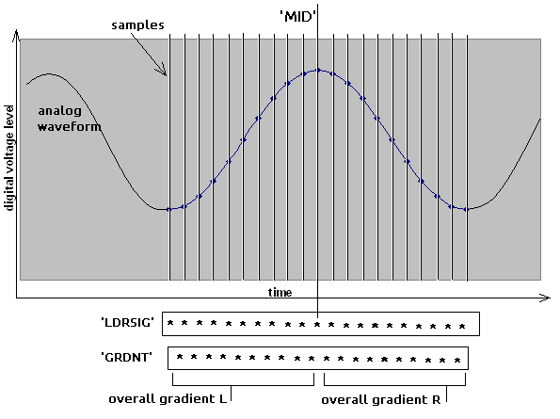
PhotoSensor. File ‘PhotoSensor.c’ contains functions that control the photosensor modules. Function ‘start_signal()’ is called when the Beetle begins to drive around in random mode, and its purpose is to start sending a square wave to the photosensor LED’s and to set up the conditions for another function, ‘signal(),’ to be called from mainloop() about every 520 microseconds. Function ‘stop_signal()’ halts the operation. Functions ‘start_signal()’ and ‘stop_signal()’ only concern the collision detection photosensors, because the wheel detection photosensors are processed according to their own timing scheme in mainloop(). However, function ‘signal()’ is used to process all photosensor signals.

Signal processing. The job of function ‘signal()’ is to analyze the input signals of the photosensor modules and in each case update a global variable ‘LDRx’ (where ‘x’ is the module number) with a 0 if a waveform is not detected, or a non-zero value if a waveform of the right frequency is detected. This non-zero value, in the case of the collision detection modules, is the difference in voltage between the most recent peak and trough of the waveform and is meant to indicate signal strength, though at present any value other than zero simply means the sensor module has triggered. When a wheel rotation photosensor module triggers, its ‘LDRx’ variable is simply updated with a ‘1.’ The “state machine” in mainloop() looks at these ‘LDRx’ variables to determine whether the photosensor module ‘x’ has triggered.
Figure 9: Photosensor input sampling
First, a switch sequence sets the function up to analyze the correct sensor module, and the analog-to-digital-converter module is used to take a new sample of the analog signal. A history of 21 of the most recent samples is logged in array ‘LDRSIG,’ each sample being a 16-bit unsigned integer that puts the voltage level somewhere between ground and +5 volts. A second array, ‘GRDNT,’ stores 20 elements, each one an indicator of the gradient between two ‘LDRSIG’ samples: +1 if the gradient is positive, -1 if the gradient is negative, and 0 if the two samples are the same value. ‘LDRSIG’ and ‘GRDNT’ are circular buffers, meaning that every time a new sample is taken, the oldest elements in the arrays are overwritten by the new values, regardless of their index.
Next, in order to see if a waveform exists, the idea is to look for “stationary points” (peaks and troughs) in ‘LDRSIG’ data. The sampling rate is optimized so that when a stationary point is located in the middle of ‘LDRSIG’ history, the ten samples on either side of it reach almost to the next or previous stationary point, but not quite (assuming a waveform of the frequency sought after). This middle point of ‘LDRSIG’ is called ‘MID’. To discover whether ‘MID’ is a stationary point, the ten oldest elements of ‘GRDNT’ are added together to represent the overall gradient to the left of ‘MID’, and the ten newest elements are added together to represent the overall gradient to the right of ‘MID’. If the left and right gradients are sufficiently positive or negative, and they oppose each other, then it can be assumed that ‘MID’ is a stationary point. A third array, ‘SPNTS’, logs a history of the two most recent stationary points, if there are any. Each element of ‘SPNTS’ has two attributes: ‘v_level’, the digital voltage level of the stationary point, and ‘count’, the number of samples between this stationary point and the previous one.
For the wheel rotation sensor modules, simply the fact that a stationary point was logged is enough information, and immediately the global ‘LDRx’ variable is updated with a ‘1.’ The collision detection sensor modules, however, need to make sure that the waveform is of the same frequency as that sent to the photosensor LEDs. To do this, the ‘count’ attributes of both logged ‘SPNTS’ are tested to see whether the stationary points are the correct length of time apart.
Every time ‘signal()’ is called for the same module, a variable ‘count’ (not the same as the ‘SPNTS’ element attribute) is incremented. If a stationary point is logged, ‘count’ is reset to ‘0,’ and until it reaches ‘12’ again the function will not look for stationary points. This prevents the same stationary point being logged more than once. If ‘count’ increments above ‘42,’ it is assumed that no waveform exists; therefore the contents of ‘SPNTS’ are cleared, ‘count’ is reset to ‘0,’ and in the case of collision detection modules the ‘LDRx’ variable is cleared as well. In the case of the wheel rotation sensor modules, the ‘LDRx’ variable is only cleared at this point if the global variable ‘bb’ has incremented over a certain point, because they need some extra time to start seeing the waveform produced by wheel rotation.

MotorControl. File ‘MotorControl.c’ contains functions that concern the motors in some way. Functions ‘move()’ and ‘pivot()’ tell the motors to turn the wheels in some way, function ‘sing()’ vibrates the motors at certain frequencies with the result that they emit a musical pitch as though they were speakers, and function ‘rand()’ generates pseudo-random decisions about moving.

Mobility. The Beetle has eight different ways that it can move: forward, backward, pivot clockwise, pivot counter-clockwise, turn forward right, turn forward left, turn backward right, and turn backward left. Forward and backward are accomplished by rotating both wheels in the same direction. To pivot, both wheels rotate in opposite directions. Turning is accomplished by holding one wheel still while the other rotates.
As explained in the stepper motor drivers section, motor operation is controlled by sending logic and phase signals to the drivers. Four phase signals are needed, two per motor – these in the program are variables ‘m1ph1,’ ‘m1ph2,’ ‘m2ph1,’ and ‘m2ph2.’ The two logic signals that control current levels in both motors are variables ‘L0’ and ‘L1’; and one last variable, ‘IEN,’ controls whether the X-OR module in the motor driver circuit inverts one set of the logic signals or not. These variables all point to output ports on the microcontroller, and as such they can only hold the values 1 (‘set’) or 0 (‘cleared’). The variable ‘IEN’ is set when the Beetle is ready to move, enabling the inverter; it is cleared when the Beetle stops so that all motor driver logic inputs can be set, allowing zero current to the motors and thus turning them off.
The only interrupt applied in the entire program is used here. First, the function ‘move()’ is called which sets up the initial conditions for the motors to behave in some way and programs the microcontroller’s timer2 module to overflow every 1,920 microseconds, triggering an interrupt each time. The interrupt routine is located in file ‘MainFunctions.c.’ The period of time between interrupts corresponds to one half-step of the motor sequence; each time the interrupt routine is executed, the phase and logic variables are updated to the required state for the next half-step of the sequence. Now, as long as the command is not given to stop, the interrupt keeps happening and the Beetle keeps moving.
The move() function has a parameter ‘mode,’ for which there are nine options – modes 1-8 set in motion one of the ways in which the Beetle can move, while mode 0 commands the Beetle to stop. In each mode of movement other than ‘0,’ the logic variables always do the same thing, while the phase variables are necessarily updated in different ways. To accomplish this, six other variables – ‘M1,’ ‘M2,’ ‘b1_1,’ ‘b1_2,’ ‘b2_1,’ and ‘b2_2’ – are given values of 1 or 0 when ‘move()’ is called, and they influence how the phases are controlled in the interrupt routine. ‘M1’ and ‘M2’ determine whether motors 1 and 2 should rotate or hold still, and the ‘b’ variables control the orientation of phase 2 for both motors, governing the direction in which they rotate.
Another ‘move()’ parameter, ‘when,’ determines whether the motion to comes into play immediately after being called, or hesitates for half a second first. This hesitation is accomplished by monitoring a variable ‘waiting’ in mainloop() which increments over time, and only setting the interrupt in motion once ‘waiting’ reaches a certain value.
There is a second mobility function, ‘pivot(),’ which simply calls ‘move()’ modes 3 or 4 depending on parameter ‘direction,’ and arranges for the movement to stop after a certain number of half-steps by giving the variable ‘bb_stop’ the value entered into parameter ‘degree’ (see section state machine). This function is not particularly useful as is, since the same thing can easily be done when ‘move()’ is called in mainloop(); however, it improves readability. If a precise pivot movement was desired (for example, forty-five degrees in a particular direction) then this function could be made even more useful.

Musical talent. There are a few times when the Beetle “sings a song,” including when the device boots up, just before it begins to wander around in random mode, when it is told to stop wandering around, and when it shuts down due to a low battery level. It does this inside function ‘sing(),’ which lasts more than a second and does not return to mainloop() during that time; for this reason, ‘sing()’ can only be called when the Beetle is standing still and no important processes need to happen.
The motors are made to emit a musical pitch by first clearing ‘IEN,’ ‘L0,’ and ‘L1’ to set the current level at 100% for all four phases of both motors, and then toggling ‘m1ph1’ and ‘m2ph1’ (phase 1 of both motors) while keeping ‘m1ph2’ and ‘m2ph2’ (phase 2 of both motors) cleared. This causes the motors to vibrate at a frequency determined by how frequently phase1 is toggled, producing an audible sound.

Pseudo-random generator. One of the main goals of project Beetle was to develop a robot that could move around by itself, making random decisions about where to go. Up to this point has been explained the systems which give the Beetle the ability to move around, and the central mainloop() that makes everything work together. Now, something has to decide in what direction to turn, what turns to make, and how much to turn. Many of these decisions are hard-coded in order to optimize the Beetle so that it is less likely to get stuck, but in cases where a bit of freedom is allowed, function ‘rand()’ makes the decision.
Incidently, Microchip’s XC8 compiler includes a pseudo-random number generator that I could probably have used instead of developing my own. However, I wished to make one from scratch for the sake of the adventure and because I would know how it works and how efficient it is. This also makes it a simple matter to add bits and pieces or tailor it to particular uses.
The core of the generator is inspired by electronics hardware (a maximal-length feedback shift register) that outputs a random sequence of bits for a certain length of time before repeating. The idea is that a buffer of bits (in this case the buffer ‘SHFTREG’ is 15 bits) is shifted to the right, the oldest bit is deleted, two of the bits are X-ORed together, and the result (the newest bit) is placed at the beginning of the buffer. This cycle then repeats. The two bits that are X-ORed together are called the “feedback taps” and their position in the buffer is chosen so that the resulting sequence of bits will go through every possible combination of (in this case) 15 bits, except all zeros, before repeating. For a shift register 15 bits long, the feedback taps are placed on the 14th and 15th bits. In the code, ‘SHFTREG’ is treated as a circular buffer with the use of a switch sequence and an iterator variable, instead of all its elements actually being shifted. This method requires that ‘SHFTREG’ actually contain 16 bits so that an extra “space” exists which is overwritten by the new bit each cycle.
The bit sequence produced will always be the same pattern of 32,767 1’s and 0’s; therefore it is a good idea to initially load ‘SHFTREG’ with a random 16-bit number – a “seed” – so that it is anybody’s guess where the sequence began. The first time the function ‘rand()’ is called, the value of ‘SHFTREG’ is ‘0.’ This state triggers a sequence that loads the value of the timer 1 counter into ‘SHFTREG’; the timer 1 module is a 16-bit counter that is used by the CCP2 module to output a square wave to the photosensor LEDs, and this will have been counting and overflowing for an indeterminate amount of time before ‘rand()’ is called. If the timer 1 counter happens to be ‘0,’ then all ‘SHFTREG’ bits are set high. From now on, the bit sequence will build on the value already in ‘SHFTREG.’
Function ‘rand()’ can make a few different types of decisions depending on the argument “type.” ‘Rand(“direction”)’ will only generate one new bit and return ‘L’ or ‘R’ depending on whether it is ‘1’ or ‘0’ – this result is meant to go straight into the ‘direction’ parameter of function ‘pivot().’ ‘Rand(“move”)’ generates three random bits and uses them to choose to return the number 3, 4, 5, or 6 – the idea here is that ‘move()’ is called with one of those numbers as the ‘mode’ argument. ‘Rand(“time”)’ generates 15 random bits and returns an integer between 1,536 and 8,191; after that number of half-steps, if the Beetle has not encountered an obstacle yet, a ‘rand(“move”)’ will be performed. ‘Rand(“degree”)’ also generates 15 new bits, but it returns a random integer between 192 and 511 – this number is tailored for the ‘degree’ parameter of function ‘pivot().’

Conclusion

The aims of project Beetle have largely been realized in that the Beetle is now a fully functioning robot that moves about on two wheels, making decisions at the whim of a pseudo-random bit sequence generator. The system is robust enough that it can cope with most situations encountered in the environment of any ordinary room – as long as there are no drop-offs! Of course, there are a hundred ways that the Beetle could be upgraded, added to, improved upon, or further developed. Following are a few major developments that I personally have in mind.
The aim to be able to complete a maze from start to finish has not been realized, but possibly this could be accomplished with existing hardware and an algorithm to map explored areas based on which sensor modules detect collisions with walls. Distances could be measured by counting wheel revolutions using the wheel rotation photosensor modules. The Beetle, instead of going in random directions, would direct itself toward unexplored areas until it found the exit point.
Currently, the photosensor technology that serves as the Beetle’s “eyes” is fairly rudimentary. Photodiodes used in place of the light-dependent resistors would undoubtedly make the system more receptive, perhaps even to the point where an object could be detected before the Beetle actually collides with it. Photodiodes also have a much faster response time and thus the frequency at which the LED’s blink could be increased to something too fast for the human eye to register; however, this would necessitate the use of more efficient signal detection software.
A fun addition to the system would be a way to prevent the Beetle from tilting during acceleration, and thus attempt to keep the chassis platform parallel to the floor at all times. This would require an accelerometer or gyroscope module to determine the rotational position of the chassis, a means of countering the rotation with another force, and PID control software. As a counter-force, perhaps the heavy battery could be made to slide back and forth lengthways along the chassis, altering the Beetle’s center of gravity; alternatively, a reaction wheel could provide the chassis with angular acceleration opposite to that of the tilting effect.
Finally, version 2 of the Beetle could be made mechanically more robust by building it out of higher-grade parts and materials. For example, some of the wooden parts could perhaps be 3D printed out of plastic, real bearings could be used, and an improved transmission would allow the Beetle to get more performance out of its motors. Also, the main electronics could be incorporated on a single printed circuit board, allowing room to downsize the Beetle or add more components.

